(Versión más estable: /_modulos4/)
- Utilizar versión chFlash ≥ 13.4.4108
la estructura flash llama a las siguientes funciones de APIWrapper.js
inicio ejercicio:
doLMSInitialize();
doLMSSetValue("cmi.core.lesson_status", "incomplete");
doLMSSetValue("cmi.core.score.raw",0);
pasar puntuación:
doLMSSetValue("cmi.core.score.raw",puntuacion); // puntuación en porcentaje (0-100%)
fin ejercicio:
doLMSSetValue("cmi.core.score.raw",puntuacion);
doLMSFinish();
- parametros.xml:
precarga="si"
mantenerSwfsFondo="no"
optimizadoWeb="si"
ejercicioUnico="UUEEPP"

-precarga ➔ acciones de intro.fla (~EiM)
tapa.useHandCursor = false;
cargando.porcentaje = "0 %";
cargando.progreso.relleno._width = 0;
cargando.porcentajeImg = cargando.porcentajeXml = cargando.porcentajeAud = "0 %";
cargando.progresoImg.relleno._width = cargando.progresoXml.relleno._width = cargando.progresoAud.relleno._width = 0;
profundidad = 1000;
sonido100 = new Sound(_level100);
sonido100.setVolume(0);
precarga = true;

tiempoProblemasCargaFichero = 3000; // si ha pasado ese tiempo y el programa aún no sabe el tamaño de un fichero (por ser 0 o undefined)
tiempoProblemasCargaTotal = 120000; // al cabo de este tiempo pasa de pantalla sí o sí
tiempoRefrescoPantalla = 333; // tiempo desde que salta verdaderamente de pantalla y se quita el mc cargando

function precargar(modo,eImg,eXml,eAud){
if(_level0._currentframe<4){
_level0.continuar();
}else{
precargar_Cont(modo,eImg,eXml,eAud)
}
}

function precargar_Cont(modo,eImg,eXml,eAud){
tapa._visible = cargando._visible = true;
cargando.gotoAndPlay(1);
cargando.porcentaje = "0 %";
cargando.progreso.relleno._width = 0;
cargando.porcentajeImg = cargando.porcentajeXml = cargando.porcentajeAud = "0 %";
cargando.progresoImg.relleno._width = cargando.progresoXml.relleno._width = cargando.progresoAud.relleno._width = 0;
precargaXML = new XML();
precargaXML.load(_level0.directorioResource + "/precarga.xml");
precargaXML.onLoad = function(){
ficherosPrecarga = new Array();
if (this.loaded && this.hasChildNodes) {
ficherosPrecarga = this.childNodes;

/// carga nombres de ficheros....
imagenes = new Array();
xmls = new Array();
audios = new Array();
if(modo){
if(eImg){
imagenes = eImg.split(",");
}
if(eXml){
xmls = eXml.split(",");
}
if(eAud){
audios = eAud.split(",");
}
}else{
/*EiM if(_level0._currentframe==2){ // menú principal
ficherosPrecargaImagenes = ficherosPrecarga[0].attributes.imagenes;
ficherosPrecargaXmls = ficherosPrecarga[0].attributes.xmls;
ficherosPrecargaAudios = ficherosPrecarga[0].attributes.audios;
}else if(_level0._currentframe==3){ // submenús
ficherosPrecargaImagenes = ficherosPrecarga[0].childNodes[_level0.ud].attributes.imagenes;
ficherosPrecargaXmls = ficherosPrecarga[0].childNodes[_level0.ud].attributes.xmls;
ficherosPrecargaAudios = ficherosPrecarga[0].childNodes[_level0.ud].attributes.audios;
}else{ // pantallas de ejercicio
ficherosPrecargaImagenes = ficherosPrecarga[0].childNodes[_level0.ud].childNodes[parseInt(_level0.ej.substr(2,2),10)-1].childNodes[parseInt(_level0.ej.substr(4,2),10)-1].attributes.imagenes;
ficherosPrecargaXmls = ficherosPrecarga[0].childNodes[_level0.ud].childNodes[parseInt(_level0.ej.substr(2,2),10)-1].childNodes[parseInt(_level0.ej.substr(4,2),10)-1].attributes.xmls;
ficherosPrecargaAudios = ficherosPrecarga[0].childNodes[_level0.ud].childNodes[parseInt(_level0.ej.substr(2,2),10)-1].childNodes[parseInt(_level0.ej.substr(4,2),10)-1].attributes.audios;
}
*/
ficherosPrecargaImagenes = ficherosPrecarga[0].attributes.imagenes;
ficherosPrecargaXmls = ficherosPrecarga[0].attributes.xmls;
ficherosPrecargaAudios = ficherosPrecarga[0].attributes.audios;
if(ficherosPrecargaImagenes){
imagenes = ficherosPrecargaImagenes.split(",");
}
if(ficherosPrecargaXmls){
xmls = ficherosPrecargaXmls.split(",");
}
if(ficherosPrecargaAudios){
audios = ficherosPrecargaAudios.split(",");
}
}
medidorImgs = new Array(imagenes.length);
medidorXmls = new Array(xmls.length);
for(i=0;i<xmls.length;i++){
medidorXmls[i] = 0;
}
medidorAudios = new Array(audios.length);
cargarFicheros(imagenes,xmls,audios);
createEmptyMovieClip("contador",_root.profundidad);
_root.profundidad += 1;

contador.t0 = getTimer();
contador.onEnterFrame = function(){
// valores carga de imgs
this.t1 = getTimer();
sumaImgBy = 0;
totalImgBy = 0;
for(i=0;i<imagenes.length;i++){
sumaImgBy += _root["tmp"+i].getBytesLoaded();
totalImgBy += _root["tmp"+i].getBytesTotal();
if(_root["tmp"+i].getBytesLoaded()==_root["tmp"+i].getBytesTotal() && _root["tmp"+i].getBytesLoaded()>0){
medidorImgs[i] = 1;
}else{
medidorImgs[i] = 0;
}
if(this.t1>this.t0+tiempoProblemasCargaFichero && !_root["tmp"+i].getBytesTotal()){ // problemas de carga
medidorImgs[i] = 1;
}
}

suma = sumaImg = sumaXml = sumaAud =0;
for(i=0;i<medidorImgs.length;i++){
sumaImg += medidorImgs[i];
}
for(i=0;i<medidorXmls.length;i++){
sumaXml += medidorXmls[i];
}
for(i=0;i<medidorAudios.length;i++){
sumaAud += medidorAudios[i];
}
suma = sumaImg + sumaXml + sumaAud;
// PORCENTAJE TOTAL
totalFicheros = medidorImgs.length + medidorXmls.length + medidorAudios.length;
if(totalFicheros>0 && cargando.progreso.fondo._width*suma/totalFicheros>=cargando.progreso.relleno._width){
cargando.porcentaje = Math.round(100*suma/totalFicheros) + " %";
cargando.progreso.relleno._width = cargando.progreso.fondo._width*suma/totalFicheros;
}

// PORCENTAJE IMGS
// (POR Nº DE IMGS CARGADAS)
/* if(medidorImgs.length>0 && cargando.progresoImg.fondo._width*sumaImg/medidorImgs.length>=cargando.progresoImg.relleno._width){
cargando.porcentajeImg = Math.round(100*sumaImg/medidorImgs.length) + " %";
cargando.progresoImg.relleno._width = cargando.progresoImg.fondo._width*sumaImg/medidorImgs.length;
}*/
// (POR BYTES DE IMGS CARGADOS)
if(sumaImgBy>0 && totalImgBy>0){
cargando.porcentajeImg = Math.round(100*sumaImgBy/totalImgBy) + " %";
cargando.progresoImg.relleno._width = cargando.progresoImg.fondo._width*sumaImgBy/totalImgBy;
}

// PORCENTAJE XMLS
if(medidorXmls.length>0 && cargando.progresoXml.fondo._width*sumaXml/medidorXmls.length>=cargando.progresoXml.relleno._width){
cargando.porcentajeXml = Math.round(100*sumaXml/medidorXmls.length) + " %";
cargando.progresoXml.relleno._width = cargando.progresoXml.fondo._width*sumaXml/medidorXmls.length;
}

// PORCENTAJE AUDIOS
if(medidorAudios.length>0 && cargando.progresoAud.fondo._width*sumaAud/medidorAudios.length>=cargando.progresoAud.relleno._width){
cargando.porcentajeAud = Math.round(100*sumaAud/medidorAudios.length) + " %";
cargando.progresoAud.relleno._width = cargando.progresoAud.fondo._width*sumaAud/medidorAudios.length;
}

salida = ficherosPrecarga + "\r" + suma + "/" + totalFicheros + " -> " + cargando.porcentaje;
salida += "\r\r" + imagenes.length + "+" + xmls.length + "+" + audios.length;
for(i=0;i<medidorImgs.length;i++){
salida += "\r" + medidorImgs[i] + "-" + imagenes[i] + " \t " + _root["tmp"+i].getBytesLoaded() + " / " + _root["tmp"+i].getBytesTotal();
}
for(i=0;i<medidorXmls.length;i++){
salida += "\r" + medidorXmls[i] + " - " + xmls[i];
}
for(i=0;i<medidorAudios.length;i++){
salida += "\r" + medidorAudios[i] + " - " + audios[i];
}

if(suma>=totalFicheros){
finalizarPrecarga(modo);
removeMovieClip(this);
removeMovieClip(contadorSaltar);
}
}
}
}
precargaXML.ignoreWhite = true;
createEmptyMovieClip("contadorSaltar",_root.profundidad);
_root.profundidad += 1;

contadorSaltar.t0 = getTimer();
contadorSaltar.onEnterFrame = function(){
// valores carga de imgs
this.t1 = getTimer();
if(this.t1>this.t0+tiempoProblemasCargaTotal){
finalizarPrecarga(modo);
removeMovieClip(this);
removeMovieClip(contador);
}
}
}

function finalizarPrecarga(modo){
if(!modo){
_level0.continuar();
}
cargando.porcentaje = "100 %";
cargando.progreso.relleno._width = cargando.progreso.fondo._width;
createEmptyMovieClip("contadorf",_root.profundidad);
_root.profundidad += 1;
contadorf.t0 = getTimer();
contadorf.onEnterFrame = function(){
this.t1 = getTimer();
if(this.t1>this.t0+tiempoRefrescoPantalla){
cargando.porcentajeImg = cargando.porcentajeXml = cargando.porcentajeAud = "100 %";
cargando.progresoImg.relleno._width = cargando.progresoImg.fondo._width;
cargando.progresoXml.relleno._width = cargando.progresoXml.fondo._width;
cargando.progresoAud.relleno._width = cargando.progresoAud.fondo._width;
tapa._visible = cargando._visible = false;
pantallaInicio._visible = false;
descargarFicheros(imagenes);
removeMovieClip(this);
}
}
}

function cargarFicheros(imagenes,xmls,audios){
for(i=0;i<imagenes.length;i++){
removeMovieClip("tmp"+i);
createEmptyMovieClip("tmp"+i,profundidad);
profundidad++;
this["tmp"+i]._x = 10000;
// this["tmp"+i]._y = 33*i;
this["tmp"+i].loadMovie(imagenes[i]);
}
for(i=0;i<xmls.length;i++){
this["xml"+i] = new XML();
this["xml"+i].load(xmls[i]);
this["xml"+i].num = i;
this["xml"+i].onLoad = function(){
if (this.loaded) {
medidorXmls[this.num] = 1;
}
}
this["xml"+i].ignoreWhite = true;
}
for(i=0;i<audios.length;i++){
this["audio"+i] = new Sound();
this["audio"+i].num = i;
medidorAudios[i] = 1;
this["audio"+i].onLoad = function(success) {
this.stop();
if (success) {
medidorAudios[this.num] = 1;
} else {
medidorAudios[this.num] = 0;
}
}
this["audio"+i].loadSound(audios[i], false);
this["audio"+i].stop();
}
}
function descargarFicheros(imagenes){
for(i=0;i<imagenes.length;i++){
this["tmp"+i].unloadMovie();
unloadMovie(this["tmp"+i]);
}
}

-cargar APIWrapper.js en .html
/*******************************************************************************
**
** FileName: APIWrapper.js
**
*******************************************************************************/

/*******************************************************************************
**
** Concurrent Technologies Corporation (CTC) grants you ("Licensee") a non-
** exclusive, royalty free, license to use, modify and redistribute this
** software in source and binary code form, provided that i) this copyright
** notice and license appear on all copies of the software; and ii) Licensee does
** not utilize the software in a manner which is disparaging to CTC.
**
** This software is provided "AS IS," without a warranty of any kind. ALL
** EXPRESS OR IMPLIED CONDITIONS, REPRESENTATIONS AND WARRANTIES, INCLUDING ANY
** IMPLIED WARRANTY OF MERCHANTABILITY, FITNESS FOR A PARTICULAR PURPOSE OR NON-
** INFRINGEMENT, ARE HEREBY EXCLUDED. CTC AND ITS LICENSORS SHALL NOT BE LIABLE
** FOR ANY DAMAGES SUFFERED BY LICENSEE AS A RESULT OF USING, MODIFYING OR
** DISTRIBUTING THE SOFTWARE OR ITS DERIVATIVES. IN NO EVENT WILL CTC OR ITS
** LICENSORS BE LIABLE FOR ANY LOST REVENUE, PROFIT OR DATA, OR FOR DIRECT,
** INDIRECT, SPECIAL, CONSEQUENTIAL, INCIDENTAL OR PUNITIVE DAMAGES, HOWEVER
** CAUSED AND REGARDLESS OF THE THEORY OF LIABILITY, ARISING OUT OF THE USE OF
** OR INABILITY TO USE SOFTWARE, EVEN IF CTC HAS BEEN ADVISED OF THE POSSIBILITY
** OF SUCH DAMAGES.
**
*******************************************************************************/

/*******************************************************************************
** This file is part of the ADL Sample API Implementation intended to provide
** an elementary example of the concepts presented in the ADL Sharable
** Content Object Reference Model (SCORM).
**
** The purpose in wrapping the calls to the API is to (1) provide a
** consistent means of finding the LMS API implementation within the window
** hierarchy and (2) to validate that the data being exchanged via the
** API conforms to the defined CMI data types.
**
** This is just one possible example for implementing the API guidelines for
** runtime communication between an LMS and executable content components.
** There are several other possible implementations.
**
** Usage: Executable course content can call the API Wrapper
** functions as follows:
**
** javascript:
** var result = doLMSInitialize();
** if (result != true)
** {
** // handle error
** }
**
** authorware
** result := ReadURL("javascript:doLMSInitialize()", 100)
**
*******************************************************************************/

var _Debug = false; // set this to false to turn debugging off
// and get rid of those annoying alert boxes.

// Define exception/error codes
var _NoError = 0;
var _GeneralException = 101;
var _ServerBusy = 102;
var _InvalidArgumentError = 201;
var _ElementCannotHaveChildren = 202;
var _ElementIsNotAnArray = 203;
var _NotInitialized = 301;
var _NotImplementedError = 401;
var _InvalidSetValue = 402;
var _ElementIsReadOnly = 403;
var _ElementIsWriteOnly = 404;
var _IncorrectDataType = 405;

// local variable definitions
var apiHandle = null;
var API = null;
var findAPITries = 0;

/*******************************************************************************
**
** Function: doLMSInitialize()
** Inputs: None
** Return: CMIBoolean true if the initialization was successful, or
** CMIBoolean false if the initialization failed.
**
** Description:
** Initialize communication with LMS by calling the LMSInitialize
** function which will be implemented by the LMS.
**
*******************************************************************************/
function doLMSInitialize()
{
var api = getAPIHandle();
if (api == null)
{
alert("Unable to locate the LMS's API Implementation.\nLMSInitialize was not successful.");
return "false";
}

var result = api.LMSInitialize("");

if (result.toString() != "true")
{
var err = ErrorHandler();
}

return result.toString();
}

/*******************************************************************************
**
** Function doLMSFinish()
** Inputs: None
** Return: CMIBoolean true if successful
** CMIBoolean false if failed.
**
** Description:
** Close communication with LMS by calling the LMSFinish
** function which will be implemented by the LMS
**
*******************************************************************************/
function doLMSFinish()
{
var api = getAPIHandle();
if (api == null)
{
alert("Unable to locate the LMS's API Implementation.\nLMSFinish was not successful.");
return "false";
}
else
{
// call the LMSFinish function that should be implemented by the API

var result = api.LMSFinish("");
if (result.toString() != "true")
{
var err = ErrorHandler();
}

}

return result.toString();
}

/*******************************************************************************
**
** Function doLMSGetValue(name)
** Inputs: name - string representing the cmi data model defined category or
** element (e.g. cmi.core.student_id)
** Return: The value presently assigned by the LMS to the cmi data model
** element defined by the element or category identified by the name
** input value.
**
** Description:
** Wraps the call to the LMS LMSGetValue method
**
*******************************************************************************/
function doLMSGetValue(name)
{
var api = getAPIHandle();
if (api == null)
{
alert("Unable to locate the LMS's API Implementation.\nLMSGetValue was not successful.");
return "";
}
else
{
var value = api.LMSGetValue(name);
var errCode = api.LMSGetLastError().toString();
if (errCode != _NoError)
{
// an error was encountered so display the error description
var errDescription = api.LMSGetErrorString(errCode);
alert("LMSGetValue("+name+") failed. \n"+ errDescription);
return "";
}
else
{

return value.toString();
}
}
}

/*******************************************************************************
**
** Function doLMSSetValue(name, value)
** Inputs: name -string representing the data model defined category or element
** value -the value that the named element or category will be assigned
** Return: CMIBoolean true if successful
** CMIBoolean false if failed.
**
** Description:
** Wraps the call to the LMS LMSSetValue function
**
*******************************************************************************/
function doLMSSetValue(name, value)
{
var api = getAPIHandle();
if (api == null)
{
alert("Unable to locate the LMS's API Implementation.\nLMSSetValue was not successful.");
return;
}
else
{
var result = api.LMSSetValue(name, value);
if (result.toString() != "true")
{
var err = ErrorHandler();
}
}

return;
}

/*******************************************************************************
**
** Function doLMSCommit()
** Inputs: None
** Return: None
**
** Description:
** Call the LMSCommit function
**
*******************************************************************************/
function doLMSCommit()
{
var api = getAPIHandle();
if (api == null)
{
alert("Unable to locate the LMS's API Implementation.\nLMSCommit was not successful.");
return "false";
}
else
{
var result = api.LMSCommit("");
if (result != "true")
{
var err = ErrorHandler();
}
}

return result.toString();
}

/*******************************************************************************
**
** Function doLMSGetLastError()
** Inputs: None
** Return: The error code that was set by the last LMS function call
**
** Description:
** Call the LMSGetLastError function
**
*******************************************************************************/
function doLMSGetLastError()
{
var api = getAPIHandle();
if (api == null)
{
alert("Unable to locate the LMS's API Implementation.\nLMSGetLastError was not successful.");
//since we can't get the error code from the LMS, return a general error
return _GeneralError;
}

return api.LMSGetLastError().toString();
}

/*******************************************************************************
**
** Function doLMSGetErrorString(errorCode)
** Inputs: errorCode - Error Code
** Return: The textual description that corresponds to the input error code
**
** Description:
** Call the LMSGetErrorString function
**
********************************************************************************/
function doLMSGetErrorString(errorCode)
{
var api = getAPIHandle();
if (api == null)
{
alert("Unable to locate the LMS's API Implementation.\nLMSGetErrorString was not successful.");
}

return api.LMSGetErrorString(errorCode).toString();
}

/*******************************************************************************
**
** Function doLMSGetDiagnostic(errorCode)
** Inputs: errorCode - Error Code(integer format), or null
** Return: The vendor specific textual description that corresponds to the
** input error code
**
** Description:
** Call the LMSGetDiagnostic function
**
*******************************************************************************/
function doLMSGetDiagnostic(errorCode)
{
var api = getAPIHandle();
if (api == null)
{
alert("Unable to locate the LMS's API Implementation.\nLMSGetDiagnostic was not successful.");
}

return api.LMSGetDiagnostic(errorCode).toString();
}

/*******************************************************************************
**
** Function LMSIsInitialized()
** Inputs: none
** Return: true if the LMS API is currently initialized, otherwise false
**
** Description:
** Determines if the LMS API is currently initialized or not.
**
*******************************************************************************/
function LMSIsInitialized()
{
// there is no direct method for determining if the LMS API is initialized
// for example an LMSIsInitialized function defined on the API so we'll try
// a simple LMSGetValue and trap for the LMS Not Initialized Error

var api = getAPIHandle();
if (api == null)
{
alert("Unable to locate the LMS's API Implementation.\nLMSIsInitialized() failed.");
return false;
}
else
{
var value = api.LMSGetValue("cmi.core.student_name");
var errCode = api.LMSGetLastError().toString();
if (errCode == _NotInitialized)
{
return false;
}
else
{
return true;
}
}
}

/*******************************************************************************
**
** Function ErrorHandler()
** Inputs: None
** Return: The current value of the LMS Error Code
**
** Description:
** Determines if an error was encountered by the previous API call
** and if so, displays a message to the user. If the error code
** has associated text it is also displayed.
**
*******************************************************************************/
function ErrorHandler()
{
var api = getAPIHandle();
if (api == null)
{
alert("Unable to locate the LMS's API Implementation.\nCannot determine LMS error code.");
return;
}

// check for errors caused by or from the LMS
var errCode = api.LMSGetLastError().toString();
if (errCode != _NoError)
{
// an error was encountered so display the error description
var errDescription = api.LMSGetErrorString(errCode);

if (_Debug == true)
{
errDescription += "\n";
errDescription += api.LMSGetDiagnostic(null);
// by passing null to LMSGetDiagnostic, we get any available diagnostics
// on the previous error.
}

alert(errDescription);
}

return errCode;
}

/******************************************************************************
**
** Function getAPIHandle()
** Inputs: None
** Return: value contained by APIHandle
**
** Description:
** Returns the handle to API object if it was previously set,
** otherwise it returns null
**
*******************************************************************************/
function getAPIHandle()
{
if (apiHandle == null)
{
apiHandle = getAPI();
}

return apiHandle;
}

/*******************************************************************************
**
** Function findAPI(win)
** Inputs: win - a Window Object
** Return: If an API object is found, it's returned, otherwise null is returned
**
** Description:
** This function looks for an object named API in parent and opener windows
**
*******************************************************************************/
function findAPI(win)
{
while ((win.API == null) && (win.parent != null) && (win.parent != win))
{
findAPITries++;
// Note: 7 is an arbitrary number, but should be more than sufficient
if (findAPITries > 7)
{
alert("Error finding API -- too deeply nested.");
return null;
}

win = win.parent;

}
return win.API;
}

/*******************************************************************************
**
** Function getAPI()
** Inputs: none
** Return: If an API object is found, it's returned, otherwise null is returned
**
** Description:
** This function looks for an object named API, first in the current window's
** frame hierarchy and then, if necessary, in the current window's opener window
** hierarchy (if there is an opener window).
**
*******************************************************************************/
function getAPI()
{
var theAPI = findAPI(window);
if ((theAPI == null) && (window.opener != null) && (typeof(window.opener) != "undefined"))
{
theAPI = findAPI(window.opener);
}
if (theAPI == null)
{
alert("Unable to find an API adapter");
}
return theAPI
}

-paquete SCORM: (Reload editor)
Archivo > Nuevo > Paquete SCORM 1.2
añadir .html a Resources
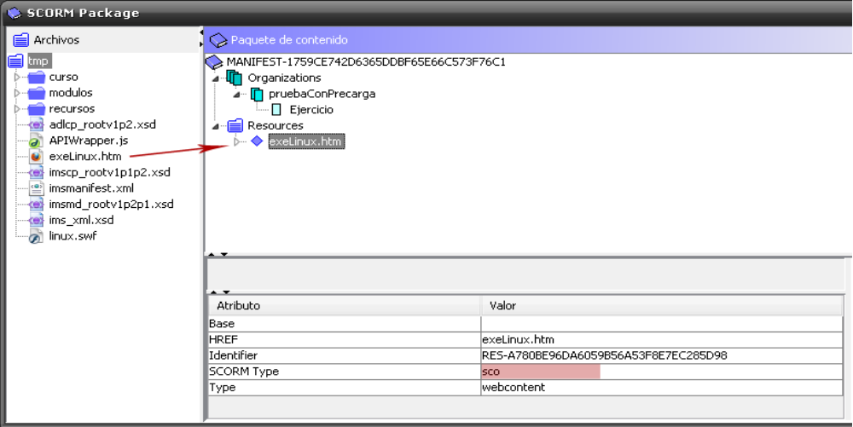
añadir Organization-Item (se crean con estos nombres pero se pueden cambiar luego en el fichero imsmanifest.xml)
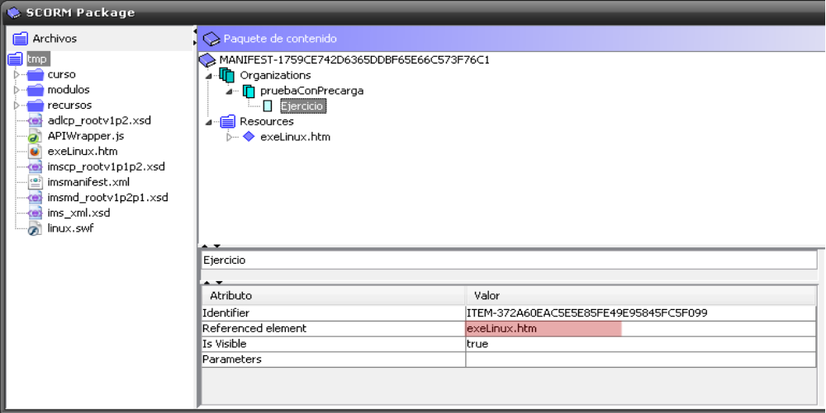
generar .zip (con Reload o a mano)

